Package

1. **Definition**: It is an encapsulation mechanism to group related classes and interfaces into a single unit which is nothing but package.  
   **Example**: All classed and interfaces required for Database operations are grouped into a single unit🡪 **java.sql package.**
2. **Advantages**:
   1. **To Resolve Naming Conflict**: That is identification of our component.
   2. **To Modularize**: It improves modularity of the application  
      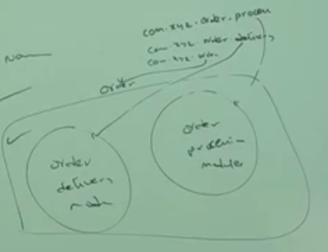
   3. **Maintainability**: It improves the maintainability of the app.
   4. **Security**: It provides security to our component.
3. d

How to name a package

1. There is one universally accepted naming convention for packages. That is to use internet domain name in reverse.  
   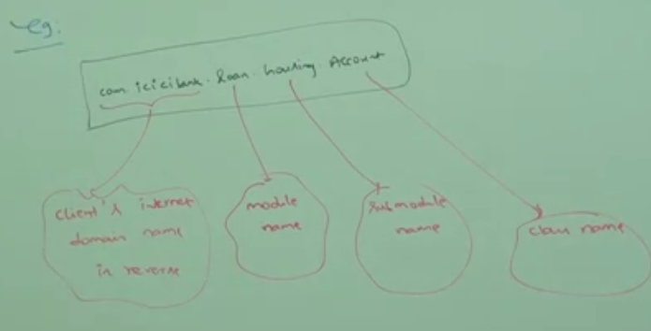
2. d

How to write package statement

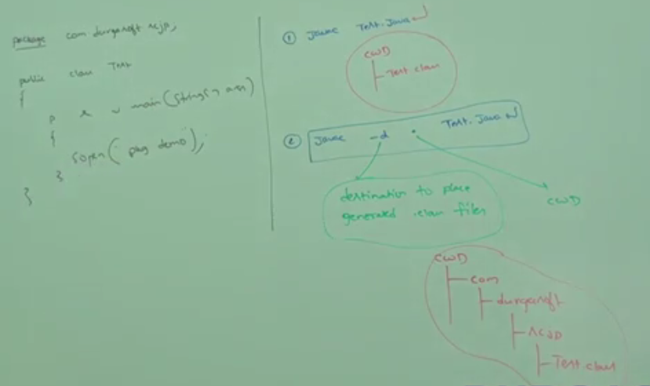

Let’s try to understand the above com.durga.scjp.Test.java

1. **javac Test.java**
   1. Generated .class file will be placed in current working directory.
2. **javac -d . Test.java**:   
   -d : directory (Destination) to place generated .class file.  
   . : current working directory  
   Generated .class file will be placed in corresponding package structure.
3. **NOTES**:
   1. If the corresponding package structure not already available, then this command will itself create corresponding package structure.
   2. Let’s try to understand 3 different javac statements  
      Suppose we have **package** 🡪 a.b.c **Class Name** 🡪 Test.java
      1. javac Test.java 🡪 Use when you are already in a/b/c package and compile program from there.
      2. javac -d . Test.java 🡪 To Store the generated class file and package structure in current working directory.
      3. javac -d F: Test.java 🡪 To Store the generated class file and package structure in different directory apart from current working directory. ☺  
         **NOTE**: if specified directory not available then we will get compile time error.
         1. ce: specified directory not found
   3. NOTE:
4. How to run a class file located in a package?
   1. Suppose we have a.b.c.Test.class
   2. we are parallel to a package.
   3. now give command
      1. java a.b.c.Test
      2. NOTE: if you say that you are in a package and you give the command
         1. java b.c.Test
5. What if we have more than one package statement?  
   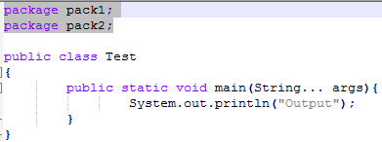

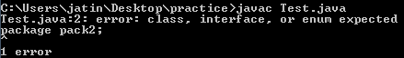

1. In any java program, the first non-comment should be package statement if it’s available otherwise we will get compile time error.  
   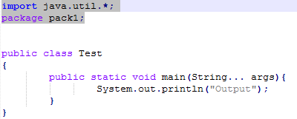
2. 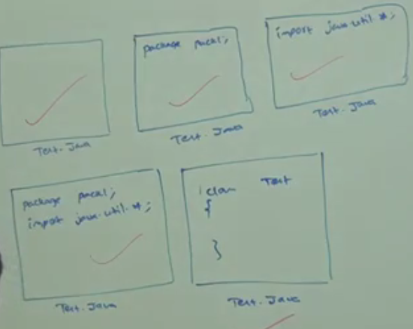
3. 